**A PROJECT REPORT**

**Team ID : NM2023TMID17330**

**Team Leader : SUBITHA S**

**Team Member : SUDHARSUN M**

**SUJITHRA M**

**SUMATHI M**

**OPTIMIZING FLIGHT BOOKING DECISIONS THROUGH**

**MACHINE LEARNING PRICE PREDICTIONS**

Introduction

* 1. **Overview**

*Flight booking decisions can be a complex and overwhelming process, with various factors to consider such as airline, departure and arrival times, layovers, and most importantly, ticket prices. With the rise of online travel agencies and price comparison websites, travelers have access to a wealth of information, but it can still be difficult to determine the best time to book and which airline to choose.*

*Machine learning algorithms have been developed to help predict flight prices, based on historical data and other relevant factors such as seasonal trends, day of the week, and airline competition. By analyzing patterns and trends in this data, machine learning models can make predictions about future prices, helping travelers make informed decisions about when to book their flights.*

*In this context, machine learning can play a key role in optimizing flight booking decisions by providing travelers with accurate and timely price predictions. This can help travelers save money and time, and make the process of booking flights less stressful and more efficient. However, it's important to note that machine learning predictions are not always 100% accurate, and travelers should still consider other factors such as their travel plans and preferences before making a final decision.*

* 1. **Purpose**

*This can help travelers save money and time, as well as make the process of booking flights less stressful and more efficient. By using machine learning algorithms to analyze historical data and other relevant factors, such as seasonal trends, day of the week, and airline competition, the models can make predictions about The purpose of optimizing flight booking decisions through machine learning price predictions is to provide travelers with accurate and timely predictions of flight prices future prices.*

*The goal is to provide travelers with a tool that can help them make informed decisions about when to book their flights, which airline to choose, and which route to take. By leveraging the power of machine learning, travelers can benefit from more accurate and timely information, which can ultimately result in cost savings and a more enjoyable travel experience.*

**Problem Definition & Design Thinking**

**2.1EmpathyMap**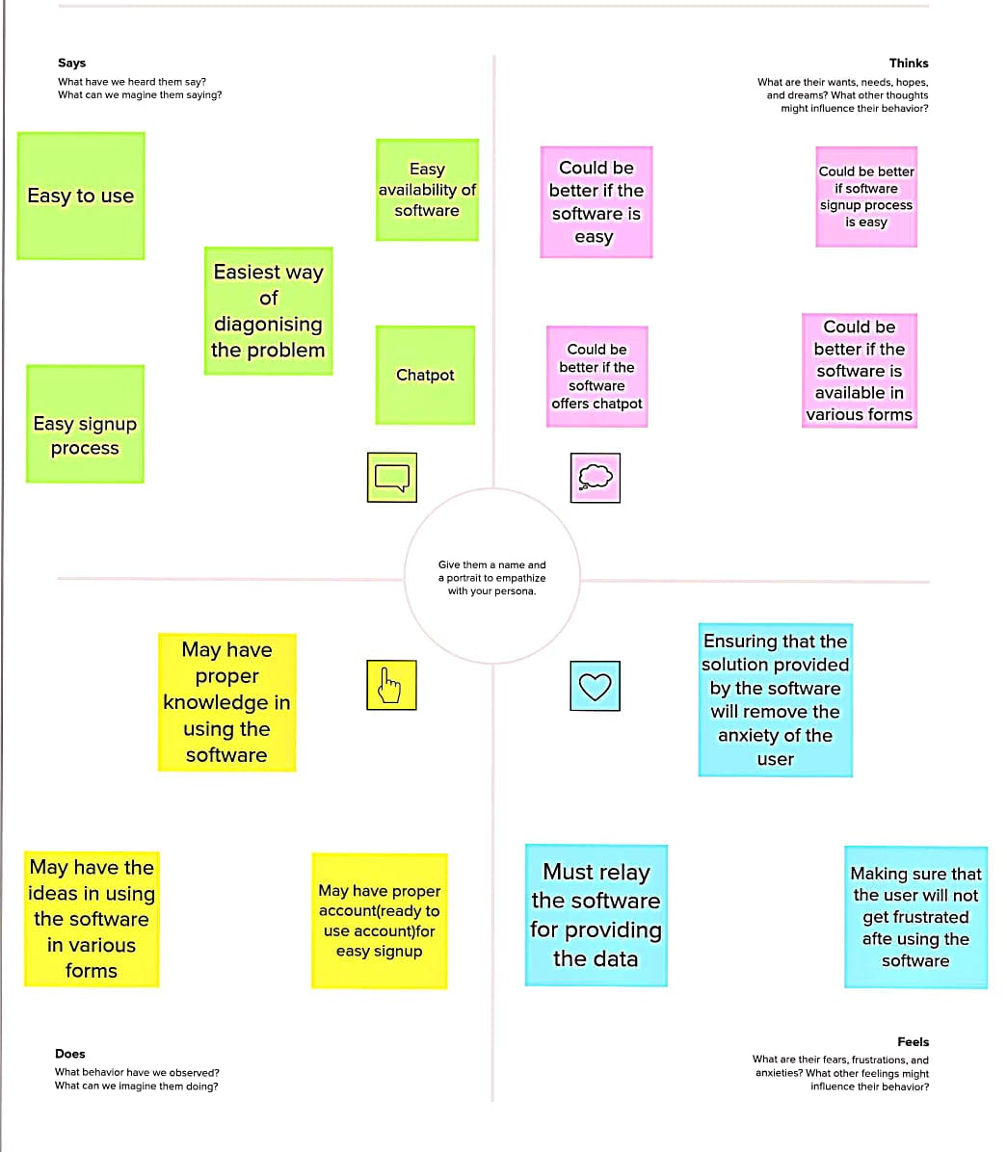

**2.2 Brainstorm & idea prioritization**

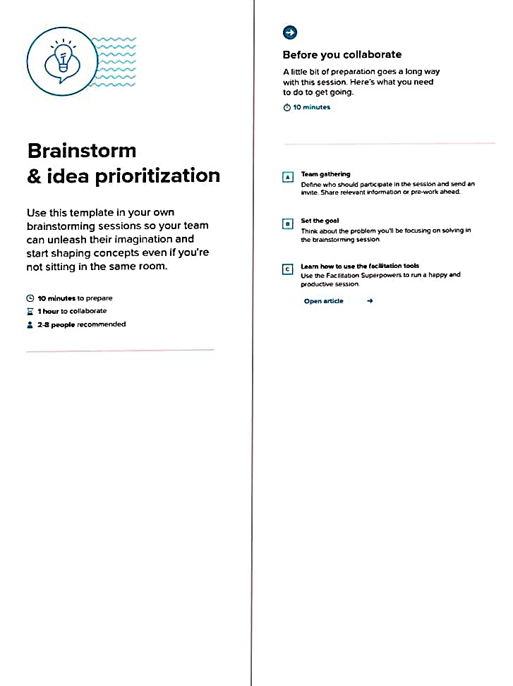





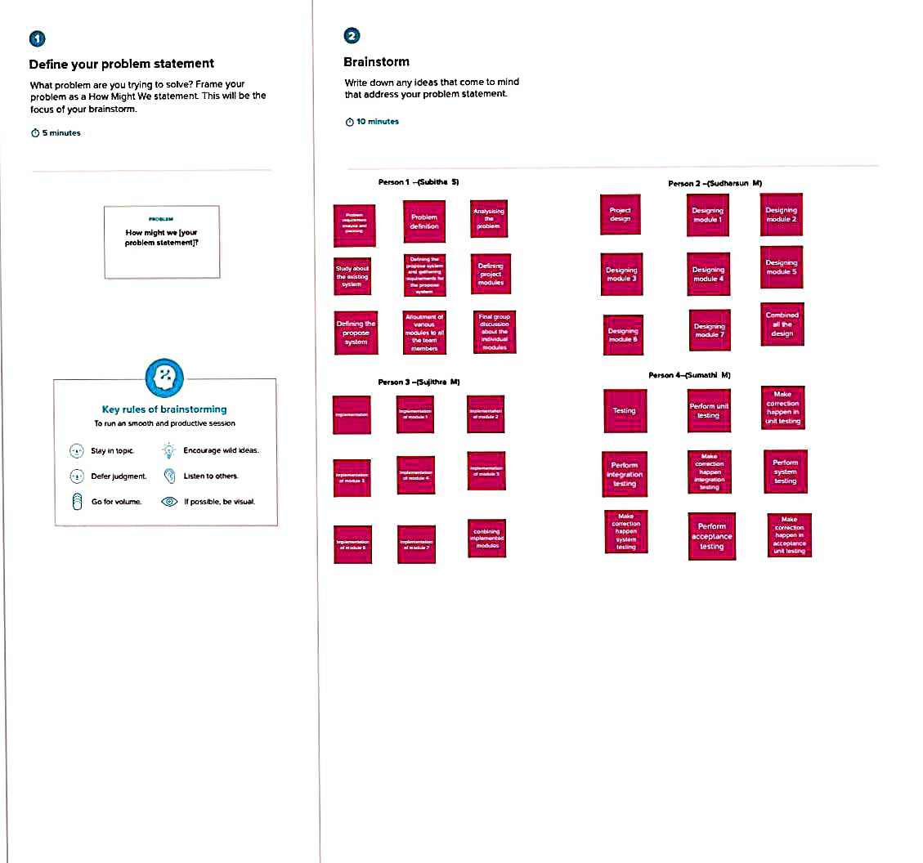

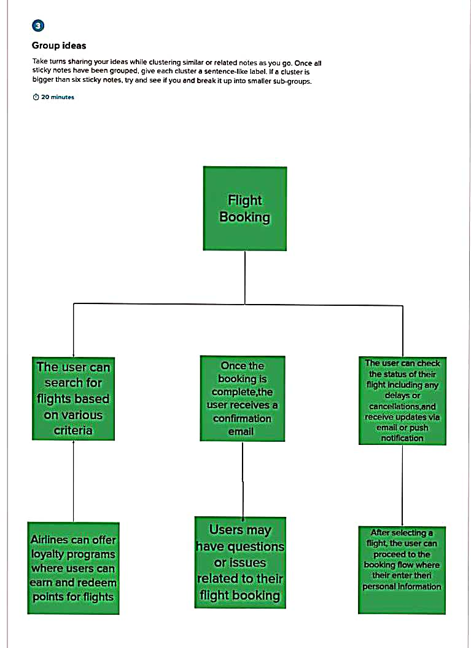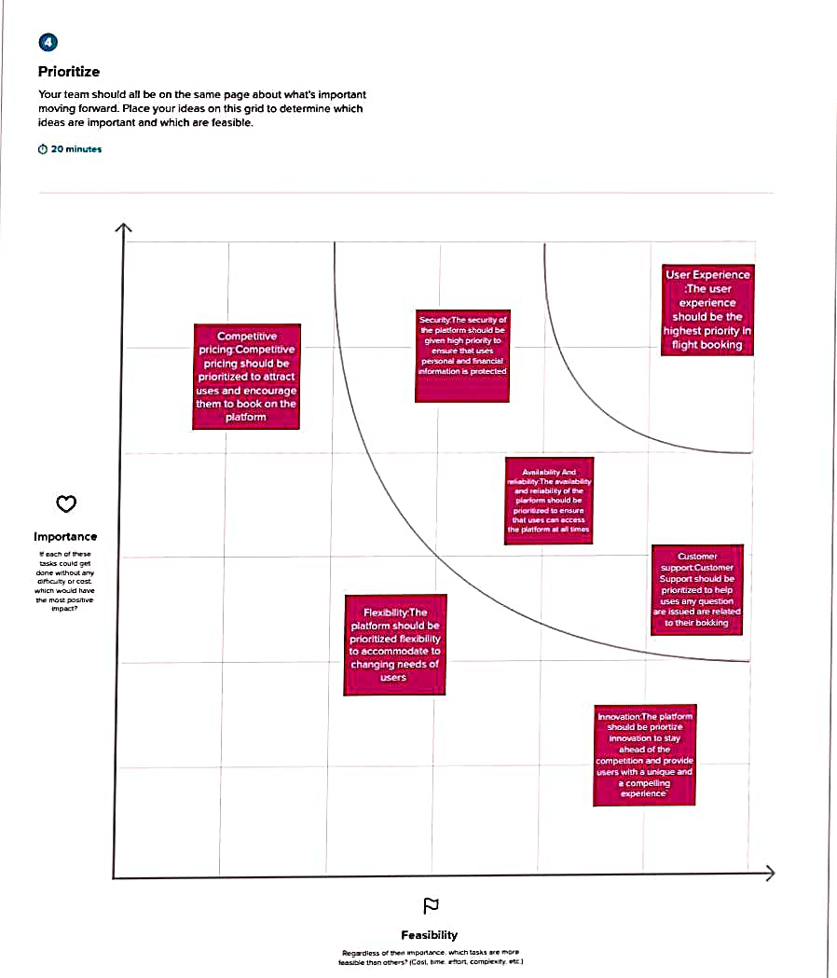

**Result**

**Output:**

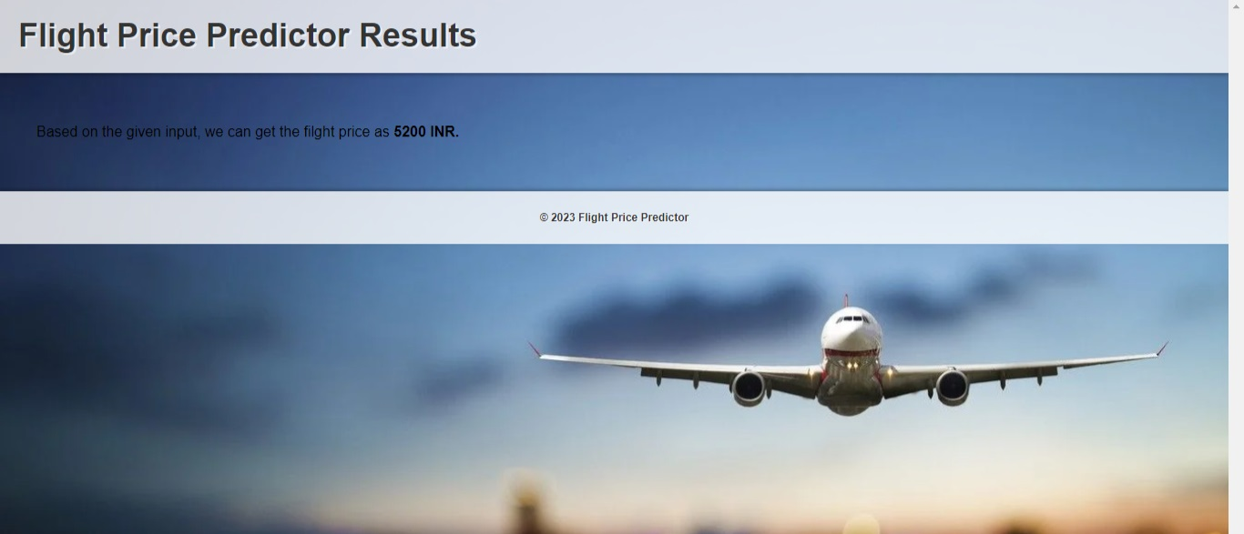

**ADVANTAGES & DISADVANTAGES**

Advantages

Cost savings: By predicting flight prices accurately, travelers can book their flights at the lowest possible prices, saving money on travel expenses.

Time savings: Machine learning algorithms can analyze large amounts of data quickly and efficiently, saving time for travelers who would otherwise have to spend hours researching flight prices themselves.

Personalization: Machine learning algorithms can take into account a traveler's specific preferences and travel history to make personalized flight recommendations and predict prices that are more relevant to their needs.

Increased accuracy: Machine learning algorithms can analyze large amounts of data and use historical pricing trends to predict future prices with a higher degree of accuracy than human experts.

Improved decision-making: Machine learning algorithms can provide travelers with more information and insights about flight prices, enabling them to make more informed and data-driven decisions when booking flights.

Disadvantages

Limited data availability: Machine learning algorithms require large amounts of high-quality data to make accurate predictions. However, there may be limitations to the data available for flight price predictions, such as incomplete or inaccurate data, or insufficient historical data to train the algorithm.

Unforeseen market changes: Flight prices are subject to many variables that can change quickly and unexpectedly, such as global events, weather conditions, and airline policies. Machine learning algorithms may struggle to adjust to these sudden changes, which could result in inaccurate predictions and potentially cost travelers more money.

Lack of transparency: Machine learning algorithms can be difficult to interpret, which means it may be challenging to understand how the algorithm arrived at a particular prediction. This lack of transparency could make it difficult for travelers to trust the predictions and make informed decisions about their travel plans.

Bias: Machine learning algorithms are only as unbiased as the data they are trained on. If the data used to train the algorithm is biased in some way (for example, if it only includes data from certain airlines or airports), the algorithm may produce biased predictions that do not reflect the true market.

Technical expertise: Developing and implementing machine learning algorithms requires technical expertise in data science and programming. This expertise may be beyond the reach of many travelers or travel companies, making it difficult to take advantage of the potential benefits of machine learning for flight price predictions.

Source Code

1. app.py(Source Code)

from flask import flask,render_template,request

import numpy as np

import pickle

model=pickle.load(open(r"model1.pkl",'rb'))

@app.route("/home")

def home():

return render_template('home.html')

@app.route("/predict")

def home1();

return render_template('predict.html')

@app.route("/pred",methods=['POST','GET'])

def predict();

x=[[int(x)for x in request.from.values()]]

print(x)

x=np.array(x)

print(x.shape)

print(x)

pred=model.predict(x)

print(pred)

return render_template('submit.html',prediction_text=pred

if __name__"__main__":

app.run(debug=false)

1. home.html

<!DOCTYPE html>

<html>

<head>

<title>Flight Price Predictor</title>

<link rel="stylesheet" type="text/css" href="style.css">

</head>

<body>

<header>

<h1>Flight Price Predictor</h1>

</header>

<main>

<form action="predict.html">

<label for="departure-airport">Departure Airport:</label>

<input type="text" id="departure-airport" name="departure_airport"><br>

<label for="arrival-airport">Arrival Airport:</label>

<input type="text" id="arrival-airport" name="arrival_airport"><br>

<label for="departure-date">Departure Date:</label>

<input type="date" id="departure-date" name="departure_date"><br>

<label for="return-date">Return Date:</label>

<input type="date" id="return-date" name="return_date"><br>

<label for="num-passengers">Number of Passengers:</label>

<input type="number" id="num-passengers" name="num_passengers" min="1" max="10"><br>

<button type="submit">Predict Price</button>

</form>

</main>

<footer>

<p>&copy; 2023 Flight Price Predictor</p>

</footer>

</body>

</html>

1. predict.html

<!DOCTYPE html>

<html>

<head>

<title>Flight Price Predictor Results</title>

<link rel="stylesheet" type="text/css" href="style.css">

</head>

<body>

<header>

<h1>Flight Price Predictor Results</h1>

</header>

<main>

<p>The predicted price for your flight from <strong>{{departure_airport}}</strong> to <strong>{{arrival_airport}}</strong> on <strong>{{departure_date}}</strong> and returning on <strong>{{return_date}}</strong> for <strong>{{num_passengers}}</strong> passengers is <strong>{{predicted_price}} USD</strong>.</p>

</main>

<footer>

<p>&copy; 2023 Flight Price Predictor</p>

</footer>

</body>

</html>

1. styles.css(Stylesheet)

body {

margin: 0;

padding: 0;

font-family: Arial, sans-serif;

font-size: 16px;

background-image: url('https://wallpaperaccess.com/full/1470792.jpg');

background-size: cover;

overflow-y: scroll;

}

header {

background-color: rgba(255, 255, 255, 0.8);

padding: 20px;

box-shadow: 0px 2px 4px rgba(0, 0, 0, 0.3);

}

h1 {

margin: 0;

font-size: 36px;

color: #333;

text-shadow: 2px 2px rgba(255, 255, 255, 0.5);

}

main {

margin: 20px;

padding: 20px;

background-color: transparent;

}

form label {

display: block;

color: white;

margin-top: 10px;

}

form input[type="text"],

form input[type="date"],

form input[type="number"],

form button[type="submit"] {

display: block;

margin-top: 5px;

padding: 5px;

font-size: 16px;

border: 1px solid #ccc;

border-radius: 5px;

}

form button[type="submit"] {

background-color: #4CAF50;

ccccccccccccccccs

}

form button[type="submit"]:hover {

background-color: #3e8e41;

}

footer {

background-color: rgba(255, 255, 255, 0.8);

padding: 10px;

box-shadow: 0px -2px 4px rgba(0, 0, 0, 0.3);

text-align: center;

font-size: 12px;

color: #333;

text-shadow: 1px 1px rgba(255, 255, 255, 0.5);

}

1. FLIGHT_PRICE.ipynb

